SIMATS ENGINEERING
ASSESSMENT TOOL 3
Exploratory Data Analysis
Practical Assessment - Annexure A
Item | Details
Course Name | Fundamentals of Data Science
Course Code | DSA04
Course Outcome | CO1: Analyse the role of data science, facets of data, and the big data ecosystem for informed decision-making (BL2)
Questions / Marks | 5 questions / 100 marks
Datasets Analysed | Education, Healthcare, Retail Sales, Banking Loan Approval, Agriculture Crop Yield
Tools Used | Python (pandas, matplotlib)

Code of Conduct
I S Aman Hussain -192425021 (Name / Reg No) certify that this submission is my original work and that I have adhered to the guidelines specified for this assessment. I understand that any violation of academic integrity rules will result in disciplinary action.
Signature of the student: S Aman Hussain

Approach Followed for All Datasets
The same eight-step EDA procedure from the assessment sheet was applied to each dataset. Every section below follows this order.
- Identify the number of rows and columns.
- Check the data type of each column.
- Find missing values and duplicates (plus incorrect entries and outliers using the 1.5 x IQR rule).
- Calculate mean, median, minimum, maximum and standard deviation.
- Draw a bar chart, histogram, scatter plot and box plot, plus a correlation heatmap.
- Identify important patterns through group comparison and correlation.
- Write five observations.
- Give a short conclusion with recommendations.

Summary of the Five Datasets
Dataset | Records | Target | Missing / Duplicates | Key Finding
1. Education | 20 | Result | 0 / 0 | Low attendance, study hours and marks go with Fail
2. Healthcare | 20 | Disease_Status | 0 / 0 | Age, sugar, BP and BMI all rise with disease
3. Retail Sales | 20 | Revenue | 0 / 0 | Fruits lead revenue; Snacks lead volume
4. Banking | 20 | Loan_Status | 0 / 0 | Salaried, score 700+ and income 45,000+ are approved
5. Agriculture | 20 | Crop_Yield_kg | 0 / 0 | Rain, fertilizer and loamy soil go with high yield

Note on small samples: Each dataset has only 20 records, so the patterns here are descriptive and should be confirmed on larger data before any decision is based on them. Strong correlations between predictors also mean that individual effects cannot be separated.

Question 1: Education Analytics - Student Performance
Problem: A college wants to identify which factors (attendance, study hours, internal marks) affect the final result (Pass/Fail).

1. Dataset Understanding
The dataset contains records of 20 students. Result is the target variable, while Attendance (%), Study_Hours (per day) and Internal_Marks are the predictors. Student_ID is only an identifier and is excluded from statistics. Data comes from the assessment sheet provided.
Column | Data Type | Nature | Role in Analysis
Student_ID | object (string) | Categorical - identifier | Unique key, not analysed
Attendance | int64 | Numeric - continuous (%) | Predictor
Study_Hours | int64 | Numeric - discrete | Predictor
Internal_Marks | int64 | Numeric - discrete | Predictor
Result | object (string) | Categorical - binary | Target (Pass / Fail)

2. Data Cleaning and Quality Checks
Check | Finding
Rows x Columns | 20 rows x 5 columns
Missing values | 0 in every column
Duplicate rows / IDs | 0 duplicate rows, 0 duplicate Student_IDs
Incorrect entries | None. All values are inside valid ranges (attendance 45-95, study hours 1-6, marks 18-48).
Outliers (IQR rule) | None found in any numeric column

The data is clean, so no imputation, removal or correction was needed. Result was kept as a categorical label for grouping.

3. Descriptive Statistics
Variable | Mean | Median | Minimum | Maximum | Std. Dev.
Attendance | 70.15 | 70 | 45 | 95 | 15.94
Study_Hours | 3.35 | 3 | 1 | 6 | 1.42
Internal_Marks | 32.95 | 33.5 | 18 | 48 | 9.09

Average attendance is 70.15% with a wide spread (std. dev. 15.94). Mean and median are almost equal in every column, so the distributions are roughly symmetric.

4. Group Comparison
Result | Students | Avg Attendance | Avg Study Hours | Avg Internal Marks
Pass | 11 | 82.45 | 4.36 | 40.00
Fail | 9 | 55.11 | 2.11 | 24.33

Passing students attend about 27 percentage points more classes, study about 2.2 more hours a day and score about 16 more internal marks than failing students.

5. Visualisations
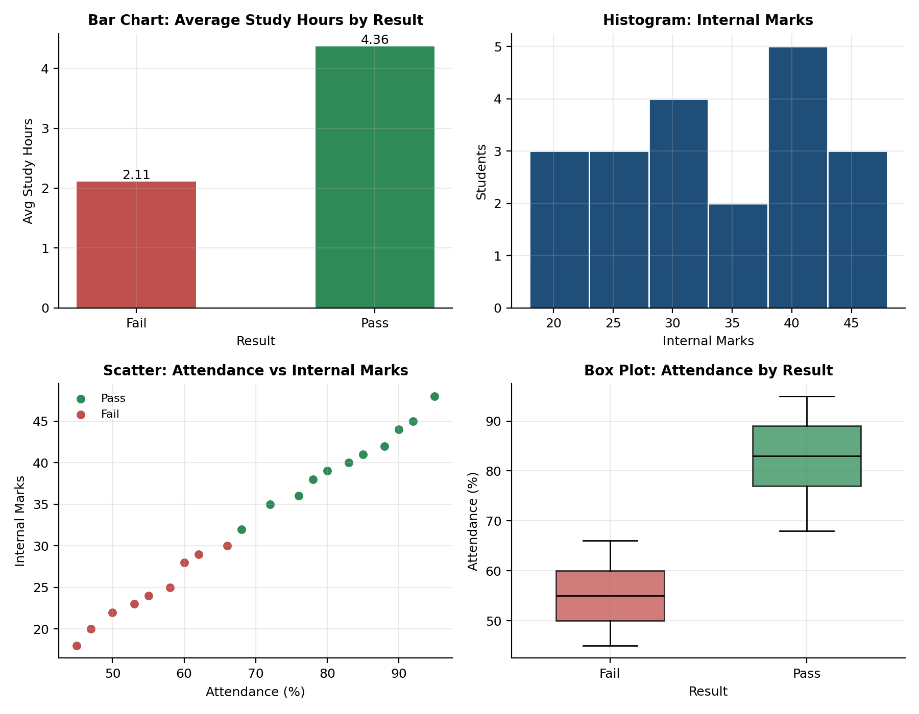
Figure: Education - bar chart, histogram, scatter plot and box plot
The scatter plot shows two clear clusters: Pass students sit in the top-right (high attendance, high marks) and Fail students in the bottom-left. The box plots of the two groups barely overlap.
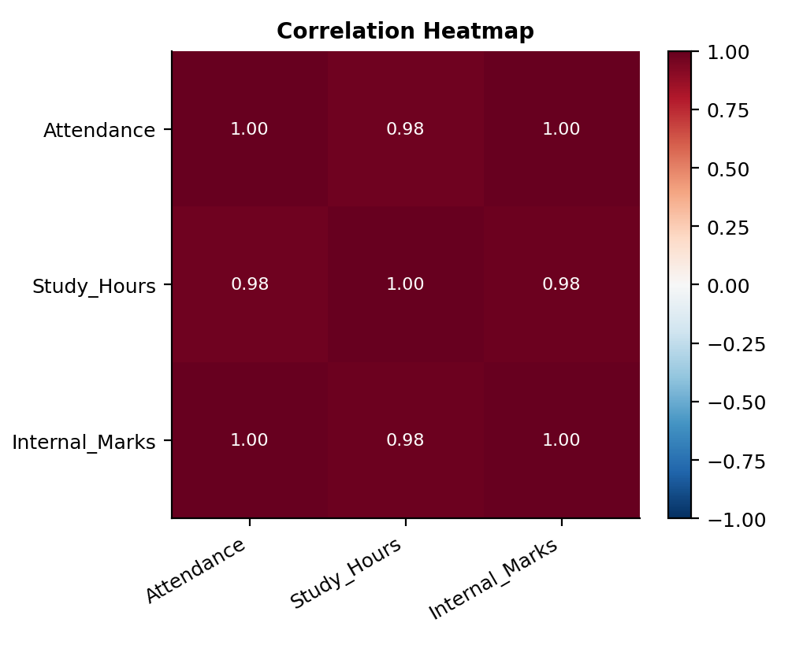
Figure: Education - correlation heatmap

6. Important Patterns
- Attendance, Study_Hours and Internal_Marks are very strongly and positively correlated with one another (r = 0.98 to 1.00).
- Results split cleanly: every Fail has internal marks of 30 or less, and every Pass has 32 or more.
- The same pattern holds for attendance: every Fail is at 66% or below, while every Pass is at 68% or above.
- Students studying 4 or more hours a day all passed; students studying 2 hours or less all failed.

7. Observations
- Of 20 students, 11 (55%) passed and 9 (45%) failed, so the classes are fairly balanced.
- Internal marks are the strongest indicator of the result, with a gap of about 2 marks between the highest Fail (30) and the lowest Pass (32).
- Attendance is a close second: the mean for Pass (82.45%) is far above the mean for Fail (55.11%).
- Study hours rise in step with attendance (r = 0.98), so students who attend regularly also tend to study more.
- Students with 3 study hours are a borderline group: S08 and S19 passed while S04, S11 and S15 failed, with attendance of 68-72% separating them.

8. Conclusion and Recommendations
Attendance, daily study time and internal marks all move together and all separate Pass from Fail. Attendance below roughly 67%, study time of 3 hours or less and internal marks below about 31 mark the at-risk group. Because the predictors are so closely related, this analysis shows association, not which one causes the result. The sample is only 20 students.
Recommendations:
- Flag students with attendance under 70% for early counselling.
- Encourage a minimum of 4 study hours a day, and use internal-mark results to trigger remedial classes.

Question 2: Healthcare Analytics - Patient Health Risk
Problem: A hospital wants to understand how age, blood sugar, blood pressure and BMI relate to disease status.

1. Dataset Understanding
The dataset contains 20 patients. Disease_Status (Yes/No) is the target. Age (years), Sugar_Level, BP (systolic blood pressure) and BMI are the risk factors. Patient_ID is only an identifier.
Column | Data Type | Nature | Role in Analysis
Patient_ID | object (string) | Categorical - identifier | Unique key, not analysed
Age | int64 | Numeric - discrete (years) | Risk factor
Sugar_Level | int64 | Numeric - continuous | Risk factor
BP | int64 | Numeric - continuous | Risk factor
BMI | int64 | Numeric - continuous | Risk factor
Disease_Status | object (string) | Categorical - binary | Target (Yes / No)

2. Data Cleaning and Quality Checks
Check | Finding
Rows x Columns | 20 rows x 6 columns
Missing values | 0 in every column
Duplicate rows / IDs | 0 duplicate rows, 0 duplicate Patient_IDs
Incorrect entries | One formatting error: the BP of P06 appeared split across cells in the source sheet ("12" and "5"). It was corrected to 125, which fits the "No" group pattern.
Outliers (IQR rule) | None found. The highest sugar (210) and BP (155) belong to P11, a valid high-risk patient, so they were kept.

After fixing the P06 entry the data is clean. High readings were retained because they are real clinical values, not errors.

3. Descriptive Statistics
Variable | Mean | Median | Minimum | Maximum | Std. Dev.
Age | 43.2 | 43.5 | 27 | 62 | 11.32
Sugar_Level | 138.65 | 137.5 | 88 | 210 | 40.33
BP | 129.75 | 129 | 108 | 155 | 14.52
BMI | 27.3 | 27.5 | 21 | 35 | 4.26

Sugar level has the largest relative spread (std. dev. 40.33 around a mean of 138.65), which suggests two distinct groups of patients. Ages range from 27 to 62.

4. Group Comparison
Disease Status | Patients | Avg Age | Avg Sugar | Avg BP | Avg BMI
Yes | 10 | 52.9 | 174.0 | 142.1 | 30.9
No | 10 | 33.5 | 103.3 | 117.4 | 23.7

Patients with the disease are about 19 years older and have sugar about 71 units higher, BP about 25 units higher and BMI about 7 points higher than those without it.

5. Visualisations
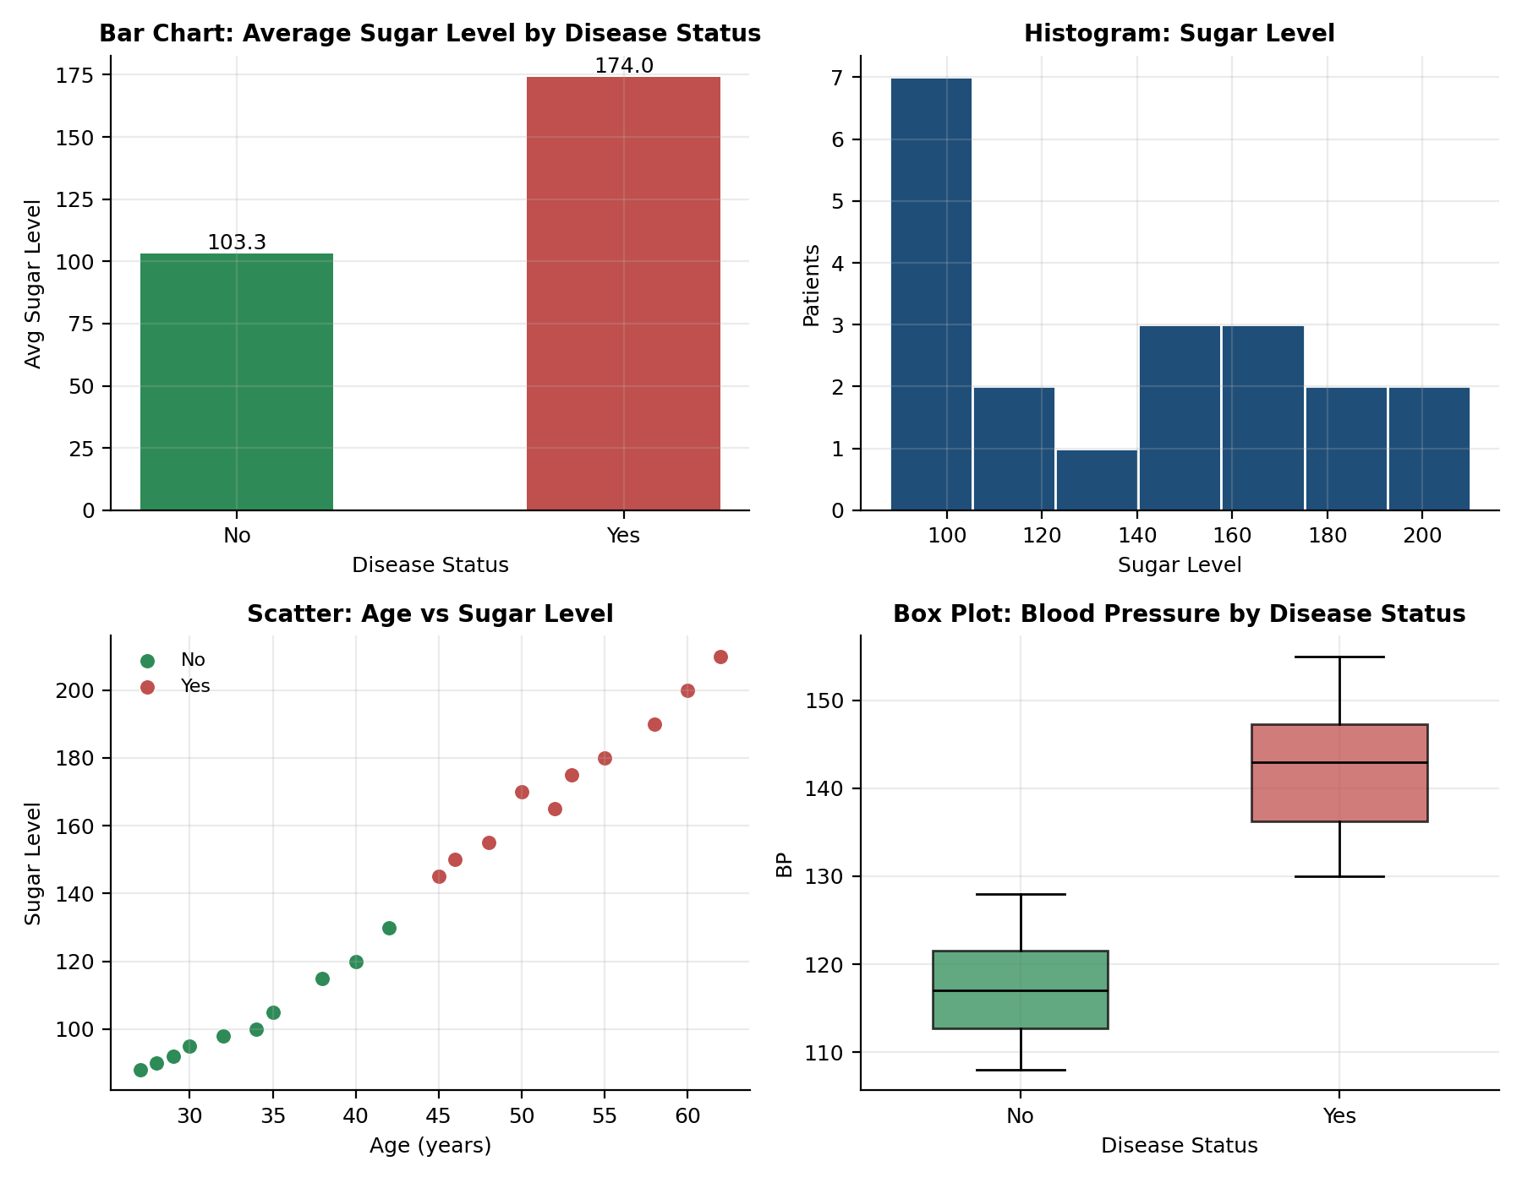
Figure: Healthcare - bar chart, histogram, scatter plot and box plot
The scatter plot of age against sugar shows a steady upward trend with two separate groups. The box plots of BP for the two groups do not overlap at all.
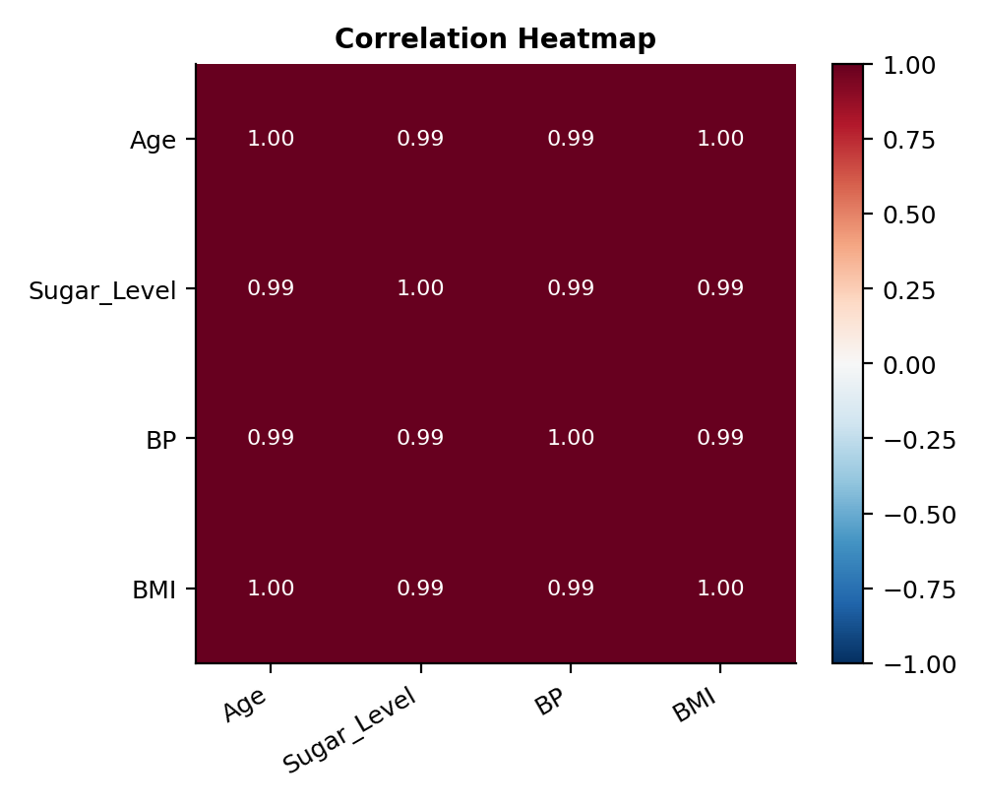
Figure: Healthcare - correlation heatmap

6. Important Patterns
- All four risk factors rise together (pairwise r = 0.99 to 1.00), so older patients also have higher sugar, BP and BMI.
- Every patient with Disease = Yes has sugar of 145 or more, and every patient with No has sugar of 130 or less.
- Every Yes patient has BP of 130 or more and BMI of 28 or more; every No patient has BP of 128 or less and BMI of 27 or less.
- Every Yes patient is aged 45 or older, while every No patient is 42 or younger.

7. Observations
- The sample is perfectly balanced: 10 patients with the disease and 10 without.
- Blood sugar shows the biggest difference between groups, with a mean of 174.0 for Yes against 103.3 for No.
- Age is a strong marker: no patient under 45 has the disease in this sample.
- BMI of 28 or more together with BP of 130 or more identifies all 10 disease cases.
- P11 (age 62) has the highest sugar (210), BP (155) and BMI (35), making this patient the highest-risk case.

8. Conclusion and Recommendations
Age, blood sugar, BP and BMI all increase together and clearly separate patients with the disease from those without. High sugar, high BP and high BMI in older patients form the main risk pattern. Since the factors are so strongly related, it is not possible to say which one matters most, and the sample of 20 is too small to generalise.
Recommendations:
- Screen patients aged 45 and above, especially those with sugar above 130 and BMI above 27, as a priority group.
- Track blood sugar, BP and BMI together rather than as separate readings.

Question 3: Retail Sales - Product Sales and Revenue
Problem: A supermarket wants to find its high-selling products and understand revenue patterns by category, price and discount.

1. Dataset Understanding
The dataset contains 20 products from 5 categories (4 products each). Revenue is the outcome measure. Price, Quantity_Sold and Discount describe each product. Discount is taken to be a percentage.
Column | Data Type | Nature | Role in Analysis
Product_ID | object (string) | Categorical - identifier | Unique key, not analysed
Category | object (string) | Categorical - nominal (5 levels) | Grouping variable
Price | int64 | Numeric - continuous | Predictor
Quantity_Sold | int64 | Numeric - discrete | Predictor / sales volume
Discount | int64 | Numeric - discrete (%) | Predictor
Revenue | int64 | Numeric - continuous | Target (outcome)

2. Data Cleaning and Quality Checks
Check | Finding
Rows x Columns | 20 rows x 6 columns
Missing values | 0 in every column
Duplicate rows / IDs | 0 duplicate rows, 0 duplicate Product_IDs
Incorrect entries | Consistency check: Revenue equals Price x Quantity_Sold for all 20 products, so there are no calculation errors. Discount is not deducted in Revenue.
Outliers (IQR rule) | None found in any numeric column

The data is clean. Because Revenue is already Price x Quantity, it is a derived column, and correlations involving it should be read with that in mind.

3. Descriptive Statistics
Variable | Mean | Median | Minimum | Maximum | Std. Dev.
Price | 54 | 50 | 20 | 100 | 22.8
Quantity_Sold | 24 | 21 | 10 | 45 | 9.67
Discount | 4 | 4 | 2 | 7 | 1.56
Revenue | 1,114 | 1,050 | 810 | 1,540 | 221.42

Average revenue per product is 1,114 (median 1,050). Price varies the most in relative terms, from 20 to 100.

4. Group Comparison
Category | Total Revenue | Units Sold | Avg Price | Avg Discount
Fruits | 5,980 | 85 | 71.25 | 5.25
Vegetables | 4,400 | 119 | 37.50 | 3.75
Grocery | 4,280 | 57 | 80.00 | 6.00
Snacks | 4,070 | 152 | 27.50 | 2.75
Dairy | 3,550 | 67 | 53.75 | 2.25

Fruits earn the most revenue even though Snacks sell the most units. Dairy is the lowest in revenue.

5. Visualisations
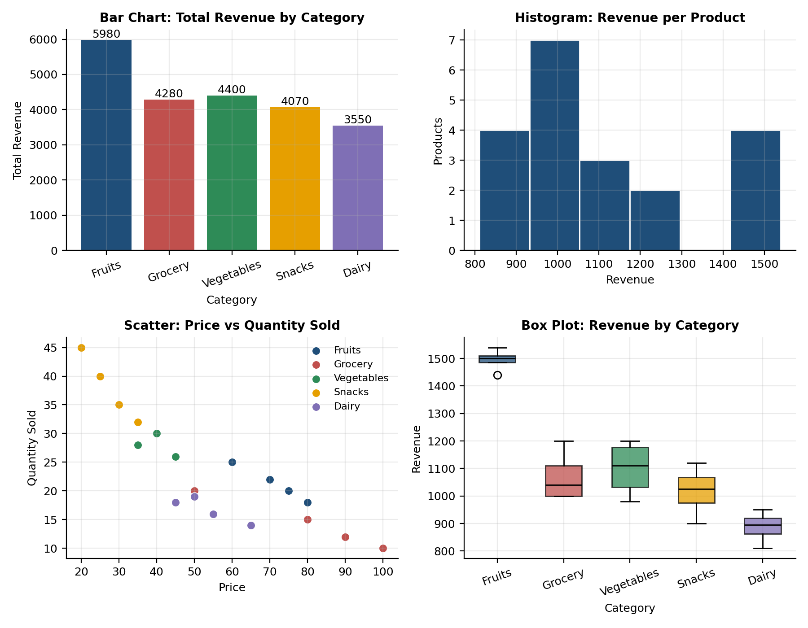
Figure: Retail - bar chart, histogram, scatter plot and box plot
The bar chart shows Fruits well ahead on total revenue. The scatter plot shows a clear downward trend: the higher the price, the fewer units sold.
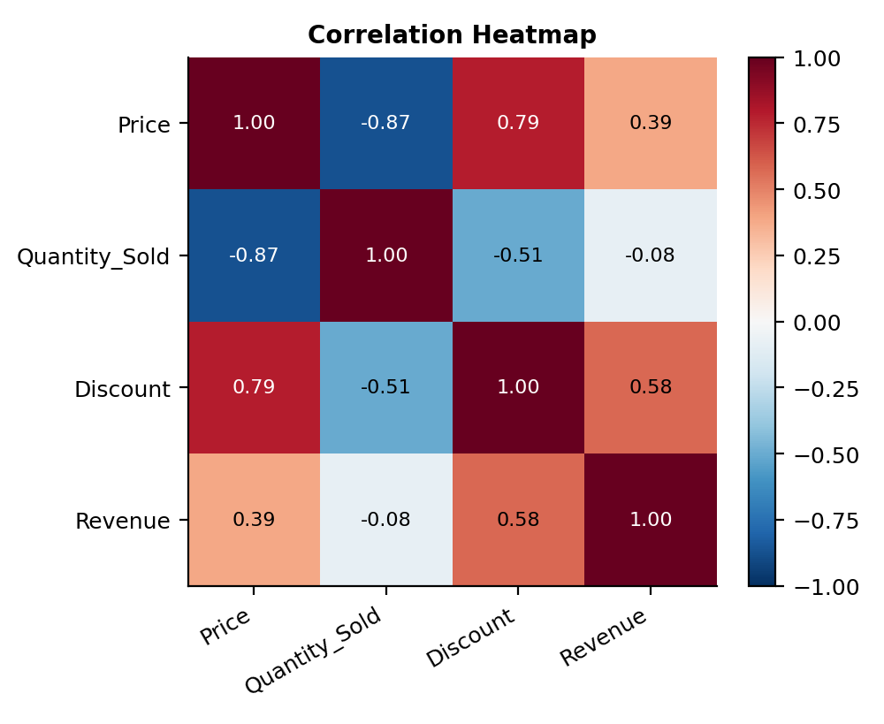
Figure: Retail - correlation heatmap

6. Important Patterns
- Price and quantity sold are strongly negatively correlated (r = -0.87): cheap items sell in high volume, expensive ones in low volume.
- Revenue has only a weak link to price (r = 0.39) and almost none to quantity (r = -0.08), because the two effects offset each other.
- Higher-priced categories carry higher discounts (price vs discount r = 0.79).
- The four highest-revenue products are all Fruits: PR09 (1,540), PR04 (1,500), PR14 (1,500) and PR19 (1,440).

7. Observations
- Fruits generate 5,980 in revenue, about 27% of the 22,280 total, the largest share of any category.
- Snacks are the volume leaders with 152 units sold, but their low average price (27.50) keeps revenue at 4,070.
- Grocery has the highest average price (80.00) and discount (6%) yet sells only 57 units, so it is mid-ranked on revenue.
- Dairy is the weakest category with the lowest revenue (3,550) and the lowest revenue per product (PR03 at 810 is the lowest overall).
- Revenue per product falls within a narrow band of 810 to 1,540, so no single product dominates the supermarket.

8. Conclusion and Recommendations
Revenue depends on the balance of price and volume rather than on either alone. Fruits combine mid-to-high prices with steady volume and lead on revenue, Snacks lead on volume, and Dairy has the lowest revenue. Higher discounts have not translated into higher sales volume in this sample. With only 4 products per category, these category results are indicative only.
Recommendations:
- Give Fruits more shelf space and keep their stock consistent.
- Review the discount policy for Grocery items, where deep discounts are not producing volume.
- Consider bundling or promoting Dairy to lift its sales.

Question 4: Banking - Loan Approval Decisions
Problem: A bank wants to identify the patterns behind loan approval using income, credit score, loan amount and employment type.

1. Dataset Understanding
The dataset contains 20 loan applicants. Loan_Status (Approved/Rejected) is the target. Income, Credit_Score, Loan_Amount and Employment_Type (Salaried, Self-employed, Unemployed) are the predictors.
Column | Data Type | Nature | Role in Analysis
Customer_ID | object (string) | Categorical - identifier | Unique key, not analysed
Income | int64 | Numeric - continuous | Predictor
Credit_Score | int64 | Numeric - discrete | Predictor
Loan_Amount | int64 | Numeric - continuous | Predictor
Employment_Type | object (string) | Categorical - nominal (3 levels) | Predictor
Loan_Status | object (string) | Categorical - binary | Target (Approved / Rejected)

2. Data Cleaning and Quality Checks
Check | Finding
Rows x Columns | 20 rows x 6 columns
Missing values | 0 in every column
Duplicate rows / IDs | 0 duplicate rows, 0 duplicate Customer_IDs
Incorrect entries | None. Credit scores (555-790) are inside the valid 300-900 range and all incomes and loan amounts are positive.
Outliers (IQR rule) | None found. The largest loan (400,000) and income (75,000) belong to C15, a valid high-credit applicant.

The data is clean and needs no corrections. Employment_Type and Loan_Status were treated as categorical variables.

3. Descriptive Statistics
Variable | Mean | Median | Minimum | Maximum | Std. Dev.
Income | 43,000 | 40,000 | 22,000 | 75,000 | 17,923.82
Credit_Score | 664 | 660 | 555 | 790 | 85.53
Loan_Amount | 223,250 | 200,000 | 120,000 | 400,000 | 83,733.21

Mean income is 43,000 and mean loan amount is 223,250. Credit scores span 555 to 790 with a standard deviation of 85.53, which indicates two clusters of applicants.

4. Group Comparison
Loan Status | Customers | Avg Income | Avg Credit Score | Avg Loan Amount
Approved | 10 | 58,800 | 743.5 | 292,000
Rejected | 10 | 27,200 | 584.5 | 154,500

Approved applicants have more than twice the income, a credit score about 159 points higher, and request loans almost twice as large as rejected applicants.

5. Visualisations
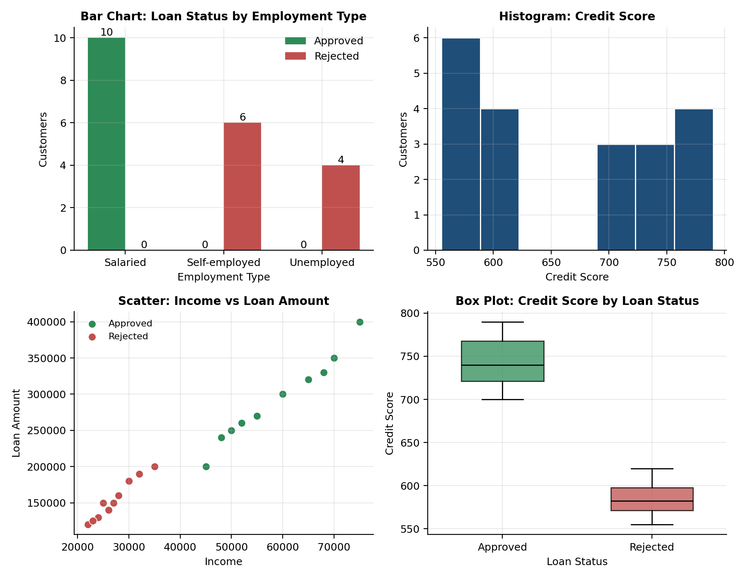
Figure: Banking - bar chart, histogram, scatter plot and box plot
The bar chart shows that all Salaried applicants were approved and all others rejected. The credit score box plots for Approved and Rejected do not overlap.
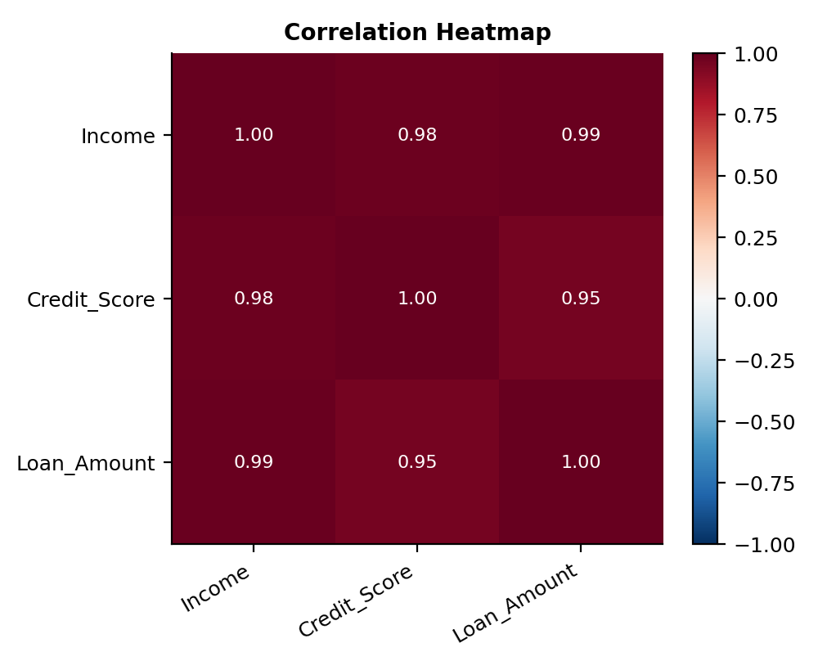
Figure: Banking - correlation heatmap

6. Important Patterns
- Employment type decides the outcome in this sample: all 10 Salaried applicants were approved, and all 6 Self-employed and 4 Unemployed applicants were rejected.
- Every approved applicant has a credit score of 700 or more; every rejected applicant is at 620 or below.
- Every approved applicant earns 45,000 or more; every rejected applicant earns 35,000 or less.
- Income, credit score and loan amount are very strongly correlated (r = 0.95 to 0.99): higher earners hold better scores and ask for larger loans.

7. Observations
- Approval is exactly 50%: 10 approved and 10 rejected applicants.
- Credit score gives the clearest numeric split, with a gap of 80 points between the highest rejection (620) and the lowest approval (700).
- Larger loans are approved more often, because loan size follows income (r = 0.99). Loan size alone is not the reason for rejection.
- All 6 Self-employed applicants (income 25,000-35,000, scores 575-620) sit below the approved ranges on both income and score, so employment type and financial strength cannot be separated in this sample.
- Unemployed applicants have the lowest incomes and scores (22,000-26,000 and 555-585) and were all rejected.

8. Conclusion and Recommendations
Approval in this dataset is linked to being salaried, having an income of at least 45,000 and holding a credit score of at least 700. The three numeric factors are tightly related, so the analysis cannot separate their individual effects. Employment type overlaps completely with the outcome, but it also overlaps with income and score, so its separate effect is unclear. A larger sample would be needed to confirm any approval threshold.
Recommendations:
- Applicants wanting approval should aim for a credit score of 700 or above.
- Collect more cases (for example, self-employed applicants with high scores) to test whether employment type or financial strength drives decisions.

Question 5: Agriculture - Crop Yield Factors
Problem: An agricultural department wants to identify the factors that influence crop yield: rainfall, temperature, fertilizer and soil type.

1. Dataset Understanding
The dataset contains 20 farms. Crop_Yield_kg is the target. Rainfall_mm, Temperature, Fertilizer_kg and Soil_Type (Loamy, Clay, Sandy) are the influencing factors.
Column | Data Type | Nature | Role in Analysis
Farm_ID | object (string) | Categorical - identifier | Unique key, not analysed
Rainfall_mm | int64 | Numeric - continuous | Factor
Temperature | int64 | Numeric - continuous | Factor
Fertilizer_kg | int64 | Numeric - continuous | Factor
Soil_Type | object (string) | Categorical - nominal (3 levels) | Factor / grouping variable
Crop_Yield_kg | int64 | Numeric - continuous | Target

2. Data Cleaning and Quality Checks
Check | Finding
Rows x Columns | 20 rows x 6 columns
Missing values | 0 in every column
Duplicate rows / IDs | 0 duplicate rows, 0 duplicate Farm_IDs
Incorrect entries | None. Rainfall (500-960 mm), temperature (25-34) and fertilizer (40-75 kg) are all realistic.
Outliers (IQR rule) | None found in any numeric column

The data is clean and needs no corrections. Soil_Type was treated as a categorical grouping variable.

3. Descriptive Statistics
Variable | Mean | Median | Minimum | Maximum | Std. Dev.
Rainfall_mm | 743 | 770 | 500 | 960 | 144.34
Temperature | 29.55 | 29 | 25 | 34 | 2.76
Fertilizer_kg | 54.75 | 54.5 | 40 | 75 | 10.51
Crop_Yield_kg | 2,820 | 2,975 | 1,800 | 3,900 | 681.41

Average yield is 2,820 kg (median 2,975 kg), and the gap between mean and median shows a slight skew toward low-yield farms. Yields range widely, from 1,800 to 3,900 kg.

4. Group Comparison
Soil Type | Farms | Avg Yield (kg) | Avg Rainfall (mm) | Avg Fertilizer (kg) | Avg Temp
Loamy | 7 | 3,514 | 893 | 66.0 | 26.7
Clay | 6 | 2,942 | 762 | 54.5 | 29.2
Sandy | 7 | 2,021 | 577 | 43.7 | 32.7

Loamy farms average 74% more yield than Sandy farms (3,514 kg against 2,021 kg), with Clay between them.

5. Visualisations
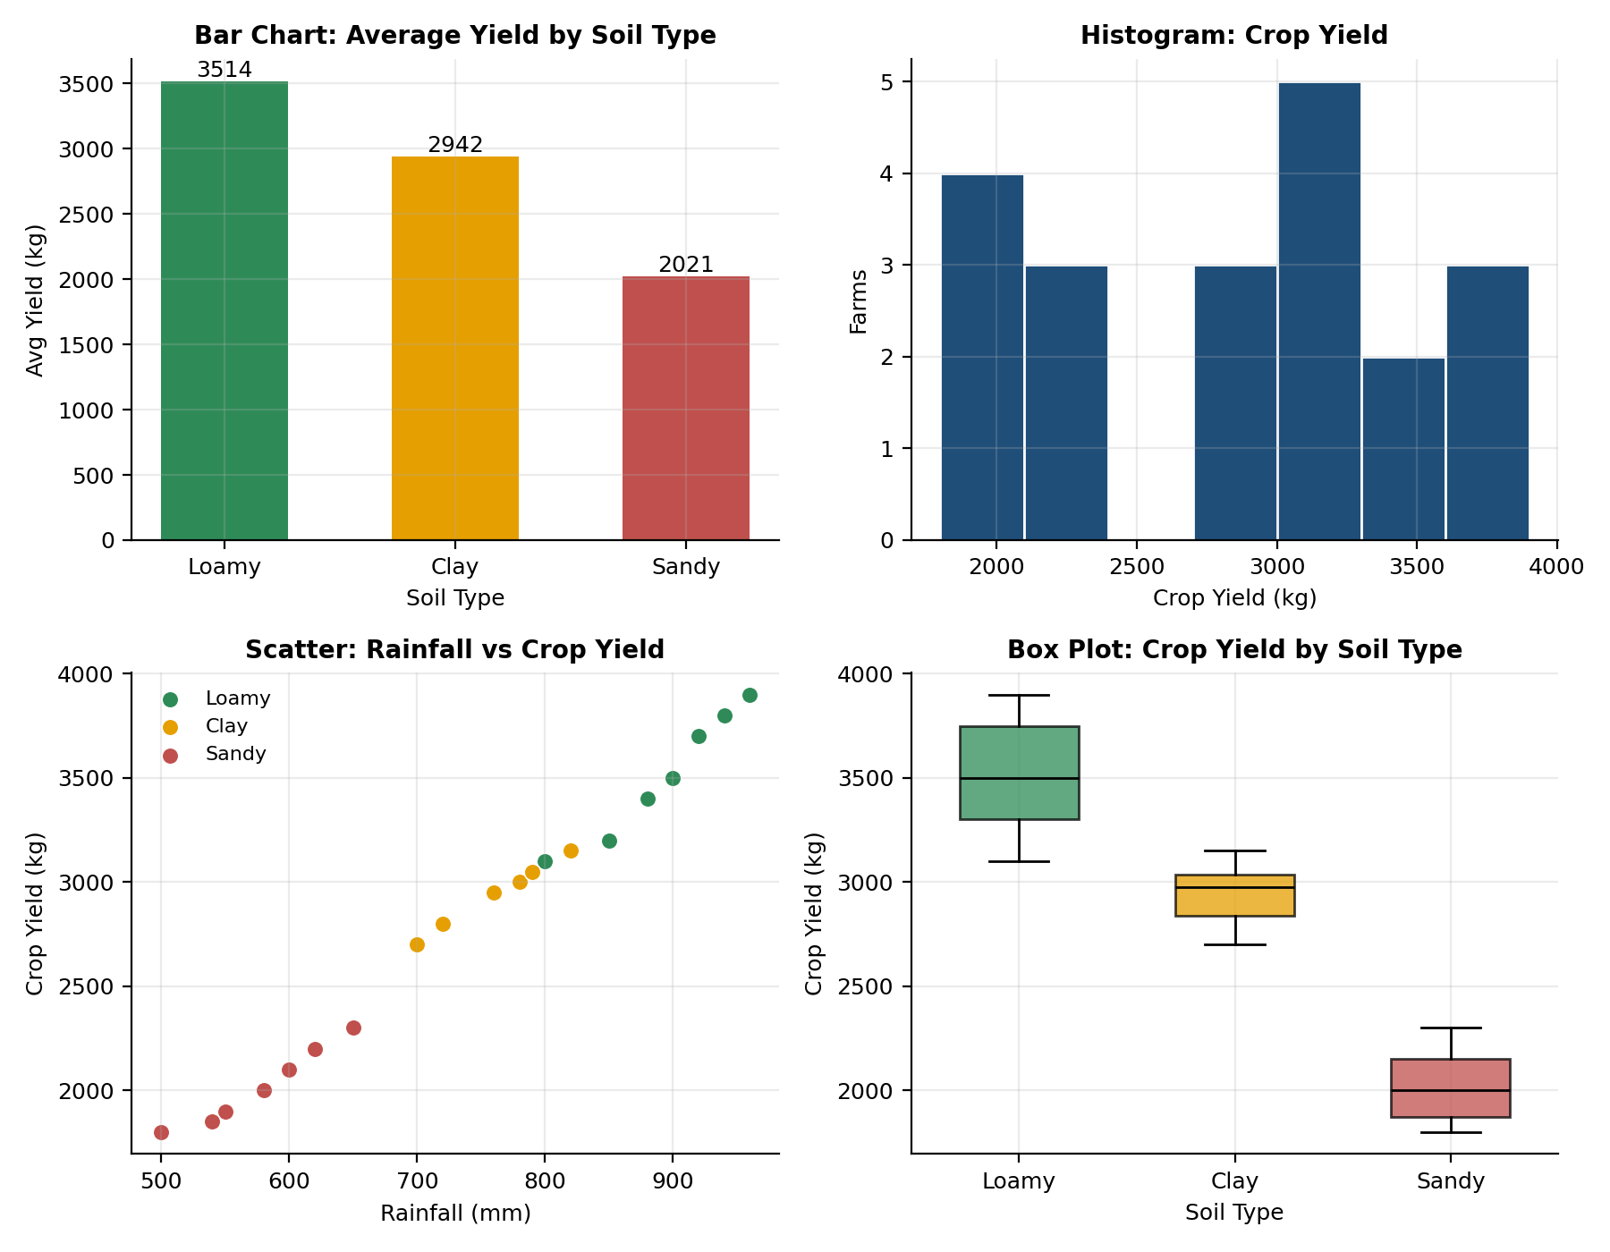
Figure: Agriculture - bar chart, histogram, scatter plot and box plot
The scatter plot shows a near-straight upward line between rainfall and yield, with Loamy farms at the top right and Sandy farms at the bottom left. The box plots of the three soil types barely overlap.
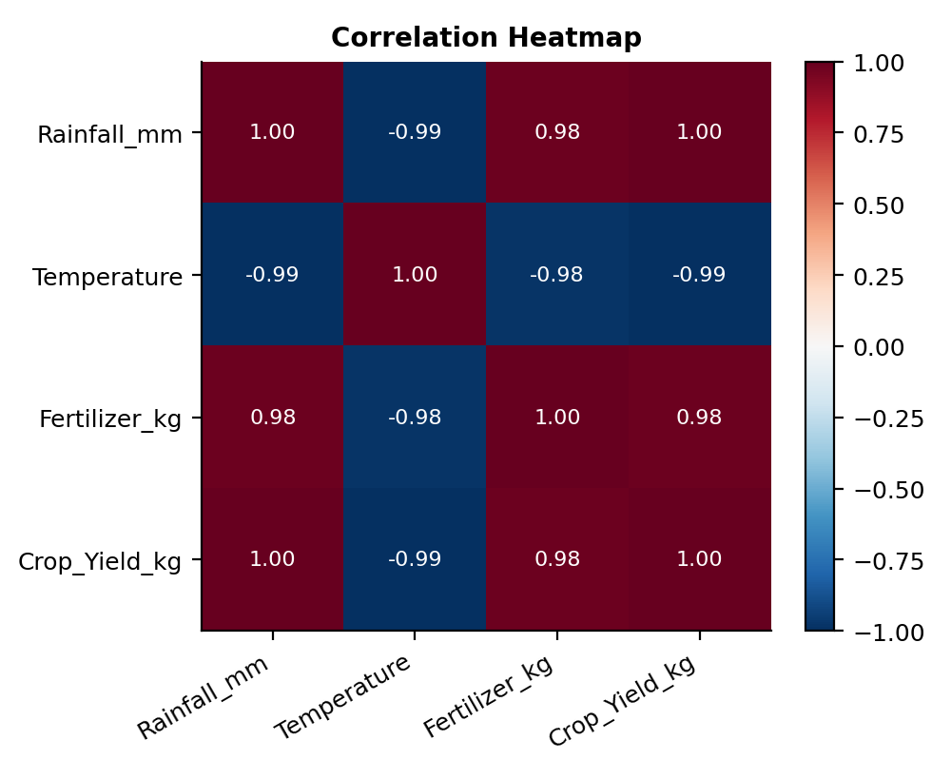
Figure: Agriculture - correlation heatmap

6. Important Patterns
- Rainfall and yield are almost perfectly positively correlated (r = 1.00); fertilizer and yield are also strongly positive (r = 0.98).
- Temperature and yield are strongly negative (r = -0.99): hotter farms produce less.
- Rainfall, fertilizer and temperature are themselves tightly linked (r = 0.98 to 0.99), because wetter farms in this sample are also cooler and use more fertilizer.
- Soil type lines up with all of these factors: Loamy farms are wettest, coolest and most heavily fertilized, and Sandy farms are the opposite.

7. Observations
- The best yield is 3,900 kg on F18 (Loamy, 960 mm, 25 degrees, 75 kg fertilizer) and the worst is 1,800 kg on F04 (Sandy, 500 mm, 34 degrees, 40 kg).
- Every Loamy farm yields 3,100 kg or more, and every Sandy farm yields 2,300 kg or less.
- Each additional 100 mm of rainfall is associated with roughly 470 kg more yield across these farms.
- Hotter farms (32 degrees and above) are all Sandy and all fall at or below 2,200 kg.
- Clay farms are consistently mid-range (2,700-3,150 kg), showing stable but not top performance.

8. Conclusion and Recommendations
Higher rainfall, higher fertilizer use, cooler temperatures and loamy soil all go with higher crop yields. Because these four factors are so closely tied together in this sample, the data cannot show which one matters most on its own. Rainfall and soil type appear to be the dominant combination, but a larger dataset with more varied conditions would be needed to separate their effects.
Recommendations:
- Prioritise irrigation support and fertilizer access for Sandy-soil, high-temperature farms, which have the lowest yields.
- Collect data from farms with mixed conditions (for example, Sandy soil with high rainfall) to separate the effect of each factor.

